Board of Directors
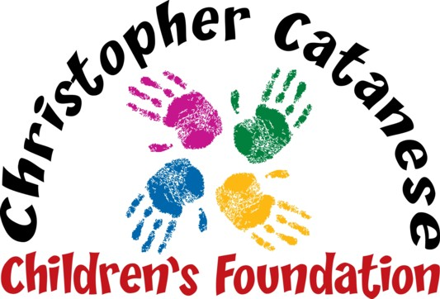
Live Laugh Love

Peter Catanese II
MaryAnn Catanese
Peter Catanese III
Linda DeBenedictis
Rev. Msgr. John R. McLaughlin, Jr.
Gail Pinkham

Program Book: Business Ad, Personal Note or Donation

Please complete and return this form with payment by November 1st to place an ad or note in our program book for our upcoming 12th fundraiser that will be held on Saturday, November 30th at Four Points by Sheraton.

Name _______________________________________Address_______________________________________

Town/State/Zip Code ____________________________ Phone _____________________________________

Email_____________________________________________________

Please check one:
⁫ $200 Business Card ___ $500 Half Page ___ $2500 Inside Back Cover___
⁫ $300 Quarter Page___ $1000 Full Page___ $5000 Back Cover ___

⁫ I (We) do not want an ad or note but would like to make a donation (any amount) $_______

Use Ad or Note from last year’s Program Book (no need to resend): _______

Special Instructions for new ads: (attach Artwork or Business Card, write Personal Notes, etc.):

_____________________________________________________________________________________________

Payment Method
Please circle one: Check, VISA, MC or AMEX Card Number_________________________________________

Expires_______ Security Code_______ Billing Zip Code _______ Email_________________________________

Email questions to info@chrisfoundation.org or call Linda at 781-762-5326, Cell 339-206-1781

