Board of Directors
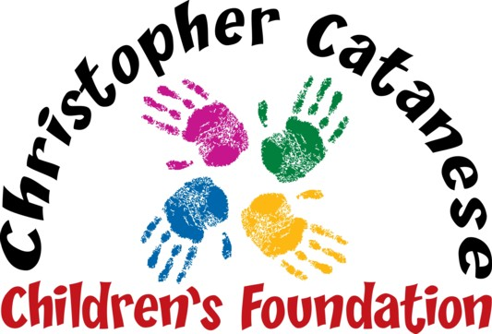
Live Laugh Love

Peter Catanese II
MaryAnn Catanese
Peter Catanese III
Linda DeBenedictis
Rev. Msgr. John R. McLaughlin, Jr.
Gail Pinkham

Ticket Form

Please complete and return this form with payment by November 1st to participate in our 12th fundraiser that will be held on Saturday, November 30th from 6-11:00 pm at Four Points by Sheraton. Seating is limited to 450 people and tickets must be purchased in advance (may also be purchased on our website: www.chrisfoundation.org).

Name _______________________________________Address_______________________________________

Town/State/Zip Code ____________________________ Phone _____________________________________

Email_____________________________________________________

Tickets are $150.00 each. You can reserve a table of 10 people for $1500.00.
Number of Tickets ____ x $150 or Number of Tables ____ x $1500 = Total Enclosed $_________

Important: Please list all guest names on this form. Attendee names will be on a list at the door when they check-in. Names can also be emailed to info@chrisfoundation.org

_____________________________________________________________________________________________

_____________________________________________________________________________________________
_____________________________________________________________________________________________

_____________________________________________________________________________________________

_____________________________________________________________________________________________
_____________________________________________________________________________________________

Payment Method
Please circle one: Check, VISA, MC or AMEX Card Number_________________________________________

Expires_______ Security Code_______ Billing Zip Code _______ Email_________________________________

Email questions to info@chrisfoundation.org or call Linda at 781-762-5326, Cell 339-206-1781

