Board of Directors
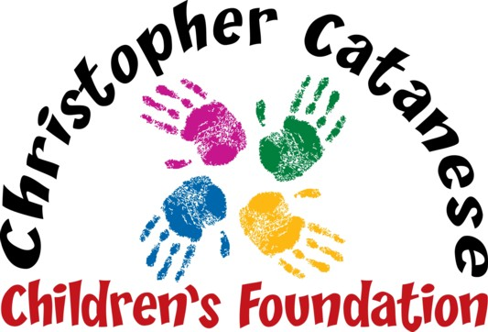
Live Laugh Love

Peter Catanese II
MaryAnn Catanese
Peter Catanese III
Linda DeBenedictis
Rev. Msgr. John R. McLaughlin, Jr.
Gail Pinkham

Auction Form

Please list auction items for our upcoming fundraiser on Saturday, November 30th at Four Points by Sheraton.

Name _______________________________________Address_______________________________________

Town/State/Zip Code ____________________________ Phone _____________________________________

Email_____________________________________________________

Please check one: Item(s) will be delivered/mailed ahead of time ___ Item(s) will be delivered that evening ____
Item(s) to be picked up by CCCF ___________

Describe the item(s) donated and list the approximate retail value for our listing:

_____________________________________________________________________________________________

_____________________________________________________________________________________________
_____________________________________________________________________________________________

_____________________________________________________________________________________________

_____________________________________________________________________________________________
_____________________________________________________________________________________________

Email questions to info@chrisfoundation.org or call Linda at 781-762-5326, Cell 339-206-1781

